Chapter 18, Solution 20.

- F (c_{n}) = c_{n}δ(ω)

F 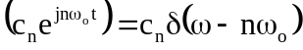

F 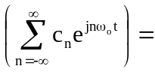 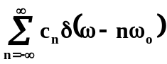

(b) 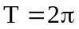 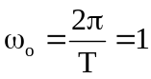

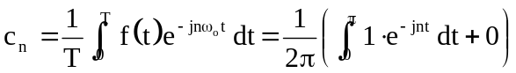

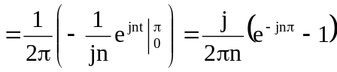
But
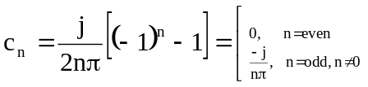

for n = 0
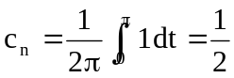

Hence
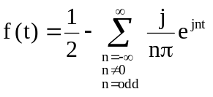
F(ω) = 